JAVA ASSIGNMENT-8 (17/11/2018)

1) Single level Inheritance:
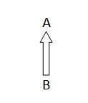

package raj;
class A
{
int wheels=2;
int brakes=2;
int clutches=1;
int tanks=1;
void bikedata()
{
System.out.println("No of wheels :"+wheels);
System.out.println("No of brakes :"+brakes);
System.out.println("No of clutches :"+clutches);
System.out.println("No of tanks :"+tanks);
}
}
class B extends A
{
int gears=0;
String color="red";
int cc=125;
void access125()
{
System.out.println("No of gears :"+gears);
System.out.println("color :"+color);
System.out.println("CC :"+cc);

}
}

public class Singlelevel {

public static void main(String[] args) {
System.out.println("Access 125cc properties are :");
System.out.println("-----------------------------");
B obj=new B();
obj.bikedata();
obj.access125();
}

}

Output:
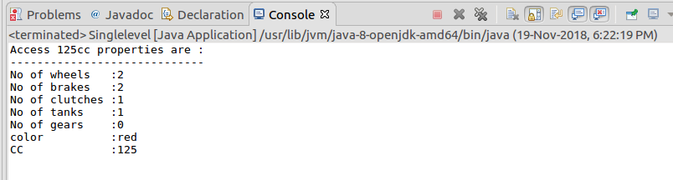

2)Multilevel Inheritance
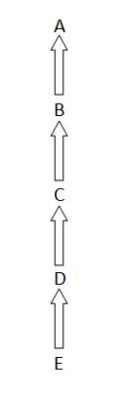

package raj;
class Marks
{
int total=30;
void marksData()
{
System.out.println("total marks:"+total);
}
}
class Telugu extends Marks
{
int telugumarks=10;
void teluguData()
{
System.out.println("Telugu:"+telugumarks);
}
}
class Hindi extends Telugu
{
int hindimarks=9;
void hindiData()
{
System.out.println("Hindi:"+hindimarks);
}
}
class English extends Hindi
{
int englishmarks=9;
void englishData()
{
System.out.println("English:"+englishmarks);
}
}

public class Multilevel {

public static void main(String[] args) {
System.out.println("Total and Telugu marks");
System.out.println("======================");
Telugu obj1=new Telugu();
obj1.marksData();
obj1.teluguData();

System.out.println("Total,Telugu and Hindi marks");
System.out.println("======================");
Hindi obj2=new Hindi();
obj2.marksData();
obj2.teluguData();
obj2.hindiData();

System.out.println("Total,Telugu,Hindi and English marks");
System.out.println("======================");
English obj3=new English();
obj3.marksData();
obj3.teluguData();
obj3.hindiData();
obj3.englishData();

}

}

Output:

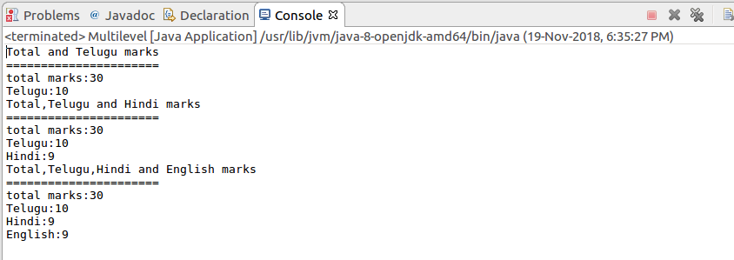

3)Heirachical Inheritance:
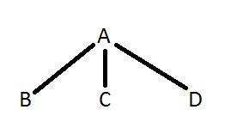

package raj;
class Bike
{
int wheels=2;
int brakes=2;
int clutches=1;
int tanks=1;
void bikeData()
{
System.out.println("No of wheels :"+wheels);
System.out.println("No of brakes :"+brakes);
System.out.println("No of clutches :"+clutches);
System.out.println("No of tanks :"+tanks);
}
}
class Access125 extends Bike
{
int gears=0;
String color="red";
int cc=125;
void access125Data()
{
System.out.println("No of gears :"+gears);
System.out.println("color :"+color);
System.out.println("CC :"+cc);

}
}
class Activa extends Bike
{
int gears=0;
String color="white";
int cc=100;
void activaData()
{
System.out.println("No of gears :"+gears);
System.out.println("color :"+color);
System.out.println("CC :"+cc);
}
}
class Shine extends Bike
{
int gears=4;
String color="black";
int cc=150;
void shineData()
{
System.out.println("No of gears :"+gears);
System.out.println("color :"+color);
System.out.println("CC :"+cc);
}
}
public class Heirarchylevel {

public static void main(String[] args) {
System.out.println("Access 125cc properties are :");
System.out.println("-----------------------------");
Access125 obj1=new Access125();
obj1.bikeData();
obj1.access125Data();

System.out.println("Activa properties are :");
System.out.println("-----------------------------");
Activa obj2=new Activa();
obj1.bikeData();
obj2.activaData();

System.out.println("Shine properties are :");
System.out.println("-----------------------------");
Shine obj3=new Shine();
obj1.bikeData();
obj3.shineData();

}

}
Output:
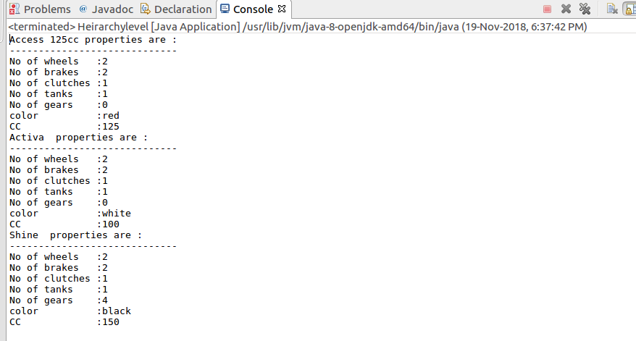

4)Multiple level Inheritance:
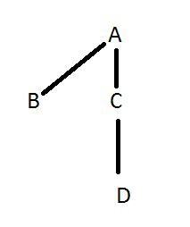

package raj;
class Mobile
{
String brand="Nokia";
String platform="Android";
void mobileData()
{
System.out.println("Brand is:"+brand);
System.out.println("Platform is:"+platform);
}
}
class Nokia3 extends Mobile
{
int model=3;
void nokia3Data()
{
System.out.println("Model name is: Nokia"+model);
}

}
class Nokia5 extends Mobile
{
int model=5;
void nokia5Data()
{
System.out.println("Model name is:Nokia"+model);
}
}
class Nokia5plus extends Nokia5
{
float model=5.1f;
void nokia5plusData()
{
System.out.println("Updated version of nokia5 is: Nokia"+model);

}
}
public class Multiplelevel {

public static void main(String[] args) {
System.out.println("Mobile1 deatails");
System.out.println("---------------------");
Nokia3 obj1=new Nokia3();
obj1.mobileData();
obj1.nokia3Data();
System.out.println("**********************");

System.out.println("Mobile2 deatails");
System.out.println("---------------------");
Nokia5 obj2=new Nokia5();
obj2.mobileData();
obj2.nokia5Data();
System.out.println("**********************");

System.out.println("Mobile3 deatails");
System.out.println("---------------------");
Nokia5plus obj3=new Nokia5plus();
obj3.mobileData();
obj3.nokia5Data();
obj3.nokia5plusData();

}

}

Output:
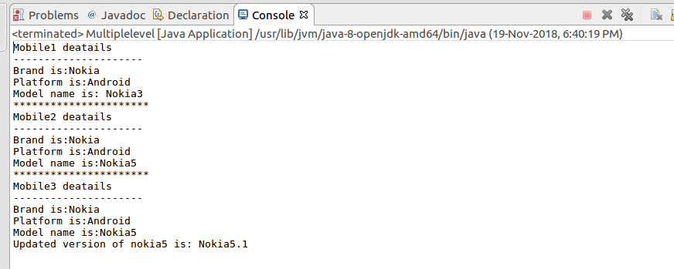

5)Hybrid level Inheritance:
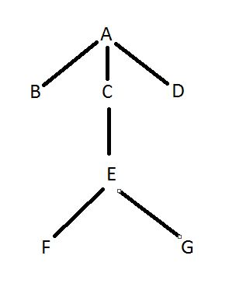

package raj;
class Phone
{
String s="Mobile details";
void phoneData()
{
System.out.println(""+s);
}
}
class Platform1 extends Phone
{
String pform1="IOS";
void platform1Data()
{
System.out.println("Operating System is: "+pform1);
}

}
class Platform2 extends Phone
{
String pform2="ANDROID";
void platform2Data()
{
System.out.println("Operating System is: "+pform2);
}
}
class Platform3 extends Phone
{
String pform3="WINDOWS";
void platform3Data()
{
System.out.println("Operating System is: "+pform3);

}
}
class Brand extends Platform2
{
String company="Redmi";
void companyData()
{
System.out.println("Company name is:"+company);
}
}
class RN5Pro extends Brand
{
String mobile1="Redmi Note5 Pro";
void rn5proData()
{
System.out.println(mobile1);
}
}
class RN6Pro extends Brand
{
String mobile2="Redmi Note6 Pro";
void rn6proData()
{
System.out.println(mobile2);
}
}
public class Hybridlevel {

public static void main(String[] args) {
System.out.println("Different Mobiles and their OS");
System.out.println("OS 1:");
System.out.println("----------------------");
Platform1 obj1=new Platform1();
obj1.phoneData();
obj1.platform1Data();

System.out.println("OS 2:");
System.out.println("----------------------");
Platform2 obj2=new Platform2();
obj2.phoneData();
obj2.platform2Data();

System.out.println("OS 3:");
System.out.println("----------------------");
Platform3 obj3=new Platform3();
obj3.phoneData();
obj3.platform3Data();

System.out.println("Mobiles of Android:");
System.out.println("----------------------");
Brand obj4=new Brand();
obj4.phoneData();
obj4.platform2Data();
obj4.companyData();

System.out.println("Mobile 1 details:");
System.out.println("----------------------");
RN5Pro obj5=new RN5Pro();
obj5.phoneData();
obj5.platform2Data();
obj5.companyData();
obj5.rn5proData();

System.out.println("Mobile 2 details:");
System.out.println("----------------------");
RN6Pro obj6=new RN6Pro();
obj6.phoneData();
obj6.platform2Data();
obj6.companyData();
obj6.rn6proData();
}

}

Output:
